Day 2:
React JS :

JS
Using JS we can read write and update html contents dynamically ie DOM Operations.

JS library or framework
Every framework and library help to improve DOM operations effectively.

React JS is an open source third party library provided by Facebook which help to develop SPA (Single Page Application).
React JS base upon Component base architecture library.
React JS support or provided Virtual DOM concept.
MPA (Multi Page Application)
Index.html welcome.html
Hyperlink
Form submit button
Using JS Code
In multi page once you connect one page to another page whole DOM get loaded in browser memory.
SPA : in Single page application we load only part the web page rather than loading whole page.
Angular, React JS and Vue JS support SPA concept.

Components Component is use to control the view or part of View in web page.

Login.html dashboard.html
Header content header content

Login page form dashboard contents

Footer content footer content

Index.html dashboard.html
Header.html 20% header.html 20%
Login.html 60% main.html 60%
Footer.html 20% footer.html 20%

Every component is use to control the view or part of the view of web page.
In React JS or any SPA we create those concept using Component
Header component,
Footer component
Main component
Logn component
Every component hold its own DOM contents. With help of these components we can do re-usability of the code.
But in SPA we create only one html page ie index.html
These components in react JS we will create using
- Function style component
- Class style components

Creating react JS projects
1st approach
npm install create-react-app -g
create-react-app welcome-demo
cd welcome-demo
npm start
(create-react-app is a third party module which help to create the react js project using legacy style).
welcome-demo is project name
2nd approach
npx create-react-app welcome-demo
(without installing it use node js third party modue)
cd welcome-demo
npm start

3rd approach
Creating react JS project using vite framework. Vite is a framework or toolkit which help to create all types of web projects. Light weighted. Improve the performance.
npm create vite@latest welcome-app
- React JS
- JavaScript
- No
- Yes
It install few dependencies
Then project ready
Copy and paste below URL on browser
http://localhost:5173/

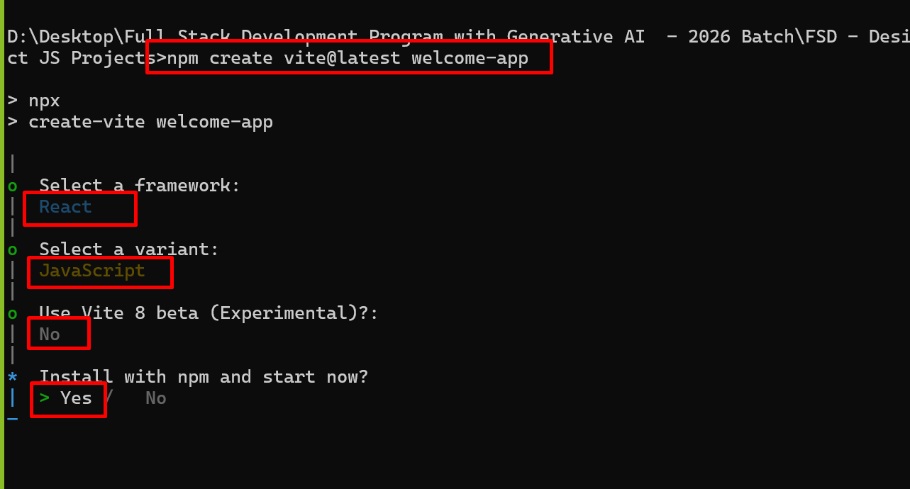

Please open the project in VS code

In React JS every function consider as component and it return html content ie DOM elements using JSX concept. Content can be static or dynamic.
In normal JS function return variable value. But in React JS component return JSX (DOM contents).

In React JS App is root components consider.

Using React JS component we are creating user defined tags.

To run the existing project

Move inside a project folder
npm run dev

